**Annexure-I**

**Research**

**PROJECT PROPOSAL FOR FUNDING FROM VC’S INNOVATION FUND**

1. **Title of the Project:** Virtual Reality integrated surveillancevehicle
2. **Project Mentor:** Dr. Jyotsna Singh
3. **Name of Project Leader:** Pallak Singh

+91 8506069673 pallak15csu144@ncuindia.edu

1. **Project Team:**

Pallak Singh – 15CSU144 Manik Kumar – 15CSU109 Vinay Garg – 15CSU258 Vineet Jain – 15CSU259

1. **Department:** Computer Science and Engineering
2. **Subject Area:** Virtual Reality, Internet of Things and iOS app development
3. **Objectives of the Project:**

This project proposes to create an economical surveillance robotic vehicle with integrated virtual reality so that such vehicles can be widely used in fields of research such as defense research and scientific explorations. This project leverages the mechanics of Virtual Reality to capture and transmit video in real time to a user at a distant location wearing the VR headset.

* 1. Capture dual video feeds on vehicle.
  2. Transmit the video to the receiver end.
  3. Display the video on the VR Headset.
  4. Provide a set of functionalities on the user end for the vehicle, such as GPS tracking, speed control.

**8. Introduction of the problem and state of the art:**

There are a variety of applications that require quick and real time action-response in the world of robots. We require rapid information with the most meticulous observations from the robots sent in the remote areas we cannot reach ourselves. This project proposes a way to make the user controlling the robot to experience those remote areas like he were there himself. This project will utilize virtual reality for just this: an immersive and interactive experience.

In recent years, we have witnessed a growing amount of automated or man-less vehicles being sent into dangerous fields. Military and scientific exploration are the biggest users of the technology being developed in this area. Military sends in robotic vehicles into areas where it’s not possible for humans to be present, be it areas infested with landmines or area under enemy control or often just casual patrolling reasons. Also, scientists often use a big amount of similar technology too, often to explore alien places, for example Chernobyl. Majority of this technology is proprietary and very limited when it comes to the video transmission aspect of it. What we’re working on is to improve upon the video related aspects of the technology. The difference between what we proposed and the existing tech is that we’ll be including a 360 Degree view from the vehicle, transmitted to us and viewed using a VR Headset (A Mobile Phone).

**9. Justification of the project:**

An accident at the Chernobyl Nuclear Power Plant rendered the entire area inhabitable for humans. A question here arises is that: given the increased radiation levels at the areas in question, how can the scientists conduct research that allows for meticulous observations without being there in person. Current systems for research in such type of remote or dangerous areas, are employing robotic vehicles that are only sending information, or are simply very limited in its video transmission aspect.

We propose to build a system that is not only providing a 360 view of the area but is also controllable using head movements for a more interactive experience. The goal here is to allow scientists to be as involved as possible in research in remote or dangerous areas.

Areas affected with radiation or areas with other inhabitable factors use monitoring systems for remote measurements at fixed locations. The

integration of these monitoring devices with a system that provides mobility and an immersive view of the field at hand can reduce the costs of installation of multiple of these systems as well as improve the task as a whole.

Virtual Reality focuses entirely on a more interactive and immersive experience. We want to leverage the mechanics of Virtual Reality to implement in fields outside entertainment, particularly research. The aim is to build an easily customisable system that can be tailored for the particular research at hand.

**10. Expected Scientific Output/Intellectual**

**Property Generation**

The system will generate the following output:

* 1. A robotic vehicle transmitting video to VR headset (a mobile phone).
  2. A mobile application for receiving the transmitted video and displaying it to the user. The video will fill the user’s entire field of view.
  3. The mobile application will send inbuilt sensor data(gyroscope, magnetometer, accelerometer) to the vehicle so as to allow user to orient the vehicle using his head (user turns his head right, vehicle turns right).

**11. Methodology**

In this section we will cover the details of the methodology that is being used to implement this project. In order to implement this project we are following a procedure that involves five major steps, as shown in the diagram below.

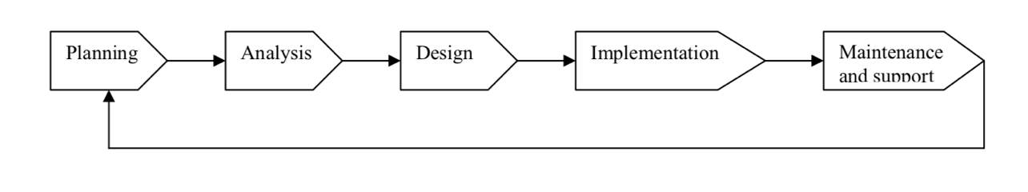

**11.1 Vehicle Circuitry Design**

When the process of designing the final electronic circuit diagram is completed, the project board circuit will be printed.

The assembly of the vehicle comprises of a microcontroller responsible for the movement of the vehicle and an on-board computer that will manage the capturing and transmission of the video feed from the cameras mounted on the vehicle to the user end of the system. The user will be wearing a VR headset.

**11.2 Software on Vehicle**

Software on vehicle is divided into two parts:

1. Software responsible for capturing the video

2. Software responsible for transmission of the video

Software on vehicle is run on the onboard computer of the vehicle. Python will used for developing the software responsible for the video aspects of the system.

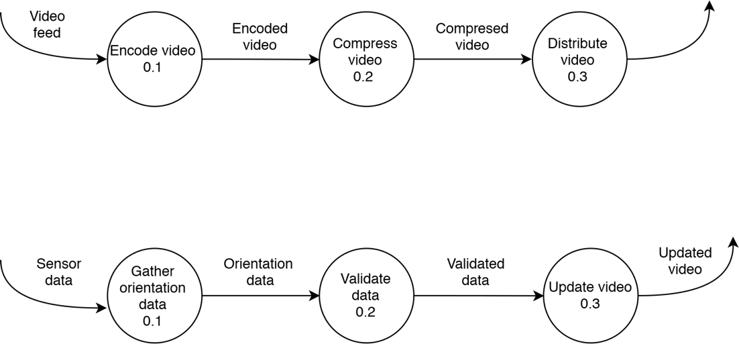

Figure 1: Data Flow Diagrams for Mobile Application

**11.3 Mobile Application**

Presently, the mobile application is being built for iOS devices. The application will be built with Objective C and Swift on Xcode environment. The application is responsible for receiving the broadcasted video and displaying it to the user wearing the virtual reality headset. The mobile application will also send gyroscope and accelerometer data to the onboard computer

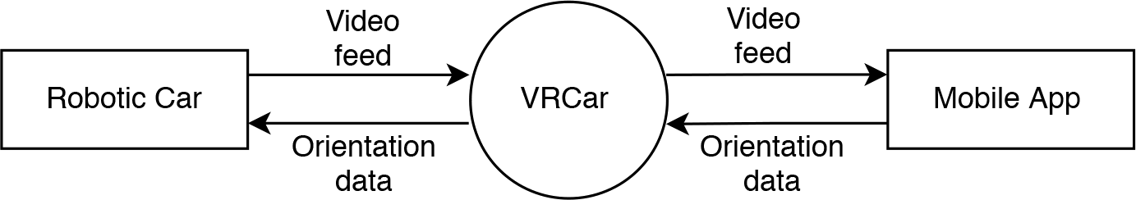

Figure 2: Context Diagram for the System

**11.4 Networking**

For data and video transmission HTTP protocol will be used. Separate data streams for data and video transmission will be created. The networking aspect of the system links the vehicle on-board computer to the mobile application, such that they could interact with each other with minimal latency.

1. **Work plan and activity**

|  |  |  |
| --- | --- | --- |
| **Milestone** | **Milestone Goal** | **Duration** |
| Feasibility Study | Idea approved by mentor. Feasibility study and literature review conducted. | 8 January 2018 - 28 January 2018 |
| Requirement Analysis | Determine and document requirements for the project. | 24 January 2018 - 8 April 2018 |
| Design Review | Confirm a design that satisfies the project requirements and are capable of fully implementing the system. | 5 February 2018 - 20 April 2018 |
| Coding and Development | Code the software and implement the hardware. | 10 February – Present |
| Testing | Determine test plans adequate for testing all the product features. | November |
| Documentation | Prepare the final documentation for the project. | November |

1. **Gantt Chart**





1. **Existing Expertise and Facilities at NCU:**
   1. Expertise of Dr. Jyotsna Singh
   2. 3D- Printer
2. **Budget Requirements:**

|  |  |  |  |  |  |  |
| --- | --- | --- | --- | --- | --- | --- |
|  | **S. No** | | **Description** | |  | **Costs** |
|  |  |  | **A. Capital** | |  |  |
| 1 | |  | Equipment | |  | 40,000 |
|  |  |  | Total(A) | |  |  |
|  |  |  | **B. Consumable** | |  |  |
| 1 | |  | Raw materials, Consumables. | |  | 4,000 |
| 2 | |  | Contingency & Others (Repair & | |  | 4,000 |
|  | Maintenance) | |  |
|  |  |  |  |  |
|  |  |  | Total(B) | |  | 8,000 |
|  |  |  | **C. Miscellaneous** | |  |  |
|  | 1 |  | Miscellaneous | |  | 2,000 |
|  |  |  | Total(C) | |  | 2,000 |
|  |  |  | *Total(A+B+C)* | |  | 50,000 |
|  |  | | |
|  |  |  |  | |  | |
|  | **Sr.** |  | **Capital** | | **Total** | |
|  | **No.** |  | **Equipment/Software** | | **(Rs. )** | |
|  | **1.** |  | Arduino Nano | | 500 | |
|  | **2.** |  | Odroid XU4 | | 6,500 | |
|  | **3.** |  | Raspberry Pi | | 3,500 | |
|  | **4.** |  | Camera(x2) | | 20,000 | |
|  | **5.** |  | Circuitry Accessories | | 2,000 | |
|  | **6.** |  | Vehicle Body | | 1,500 | |
|  | **7.** |  | Networking Hardware | | 5,000 | |
|  | **Total** |  |  | | 40,000 | |